Abstract— One of the major applications of Internet of Things (IoT) is waste management. The IoT-based smart garbage monitoring system is a web-based system that uses a wireless network for data transfer and exchange to provide IoT services for efficient garbage discharge. In a smart garbage system, sensors monitor the capacity of the smart garbage bins and communicate the information to the microcontroller. The information collected on each bin is then processed and transferred to the mobile application using Wi-Fi to provide the IoT services for garbage disposal accordingly. Information is updated after every garbage disposal process of the smart bins and the location and number of smart bins to be discharged show on the mobile application. The proposed IoT technique of waste management contributes to optimal waste level detection and efficient solid waste management.

Smart Garbage Management System Using Internet of Things (IOT)
Senthil Pitchappan V
BE. Electronics and Communication Engineering
Vellammal College of Engineering and Technonlgy
Madurai,Tamil Nadu
senthilvalliappan99@gmail.com

Index Terms—ESP 32, MIT App Inventor, Waste Management, Firebase, DHT11, Ultrasonic Sensor

INTRODUCTION
Waste is one of the major problems of mankind on our planet. Environmental pollution due to garbage overflow leads to diseases and illnesses such as malaria, dengue, cholera and diarrhea. The smart waste management system using Internet of Things techniques is an innovative strategy that has enabled the management of solid waste smartly and cost efficiently, thus improving the environment and wellbeing of the people. The wireless ultrasonic sensors help to measure the exact level of solid waste in the smart bins and notify the authorities via the smart phone application. This helps to optimize waste management by increasing the efficiency of keeping track of trash bins, reducing the fuel costs of waste trucks and waste collection time.

ELECTRONIC DESIGN

ESP32
The ESP32 is a microcontroller and a Wi-Fi module which enables access to Wi-Fi or the internet. Projects using an ESP32 module can be made wireless. It is one of the most

commonly used microcontrollers in the IoT platform. The data communication process here takes place through the TX and RX pins. It also has some inbuilt sensors and other functions that can be used to convenience. The ESP32 is used in the smart garbage system as an interface with sensors, according to the requirements. Using the wireless function the ESP32 is configured to the cloud.

Ultrasonic Sensor
The purpose of an ultrasonic sensor is to measure distance. It does this with high precision and accuracy. It is able to measure any distances from 2cm to 400cm or from 1 inch to 13 feet. When there is an object in the way of the sensor, an ultrasonic wave at the frequency of 40KHz is emitted and bounced off the object back to the sensor. The time that the ultrasonic wave takes to strike the object and come back is used to calculate the distance

These sensors are placed inside garbage bins. They consistently check the level of garbage by calculating the distance between the sensor and the garbage. When the garbage in the bin is more than 60% alerts are sent to pick up the trash.

DHT11 Temperature and Humidity Sensor

The DHT11 temperature and humidity sensor is a basic temperature and humidity sensor. It consists of a capacitive humidity sensor and a thermistor that measures the surrounding air and gives a discreet output. It gets a new data every 2 seconds so the sensor readings are up to 2 seconds old. When garbage is not disposed of humidity increases due to increasing toxicity levels. We use this information to send alerts when these levels reach a certain threshold.

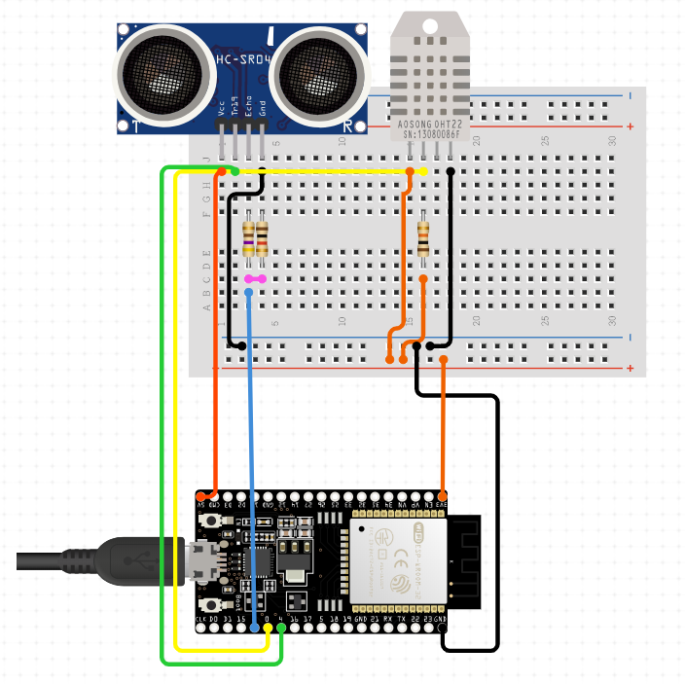
Figure 1. Hardware components

DESIGN AND MODELLING
The smart garbage system uses apps that have been linked to the microcontroller (ESP32) and the real time data of the cloud. When a user sends an alert via the smart garbage app, the owner receives a request to send a garbage truck to pick up the trash along with the location. The apps used by the user and owner were created using the MIT app inventor. The model is shown in figure 2.

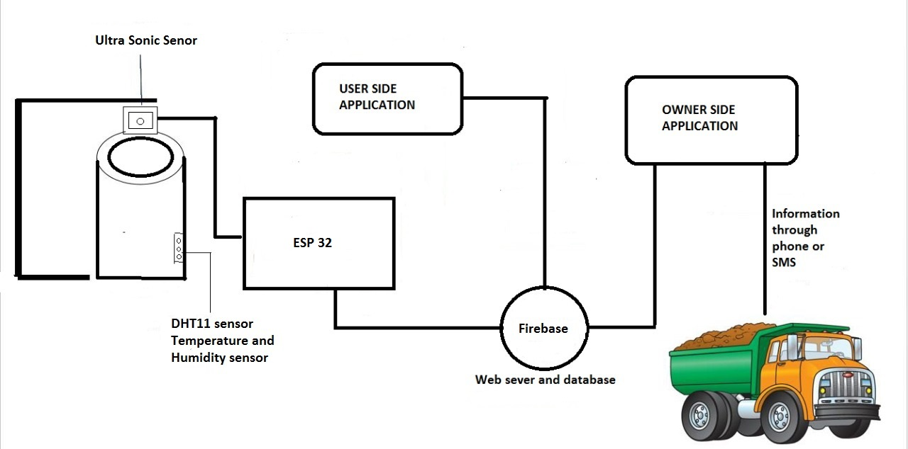
Figure 2. Model and system design

Sensors
A smart garbage bin consists of sensors that are constantly updating data based on the conditions in the bin. The ESP32 was programmed to send an alert every time one of the sensors reached a threshold i.e., if the ultrasonic sensor detected that the level of garbage was above 60% or if the DHT11 detected that the humidity was too high. All the data from the sensors is updated in real time to the cloud.

Firebase
Firebase is used in the development of apps. It provides a real time database which is a cloud hosted database. The database can store and sync data and is still available even when offline. The microcontroller gets values from the sensors and updates this information to the cloud. Since the cloud is also linked to the apps, the information is then sent to the applications. There is a constant transfer and storage of data.

MIT App Inventor
MIT app inventor allows the development of android application. According to the requirements of the app different options can be selected from the design palette. The two apps were created so one could be used by clients and the other for the owner to access. The apps receive and transfer data through firebase. Data received from the microcontroller is sent to the user and owner apps. If users face any issues there is a report system that allows them to place complaints. When a truck does not arrive to pick up the garbage the app can be used to report this delay and request for an immediate clearage of the garbage.

Flowchart
Each garbage bin is fitted with an ESP32 microcontroller, an ultrasonic sensor and a DHT11 temperature and humidity sensor. The sensors are interfaced with the microcontroller. Calculations are made to precisely calculate the levels of garbage and humidity in the bin. The smart garbage system works on a simple logic, while constantly checking the conditions of the bin. The basic concept is that if the levels in a bin are found to be less than 60% then this data is recorded on the user and owner apps. Otherwise if the levels are greater than 60% then an alert is sent from the user’s app requesting for the garbage to be collected. The owner monitors the alerts and trucks going out for pick-up. If the bin is empty this process exits the loop.

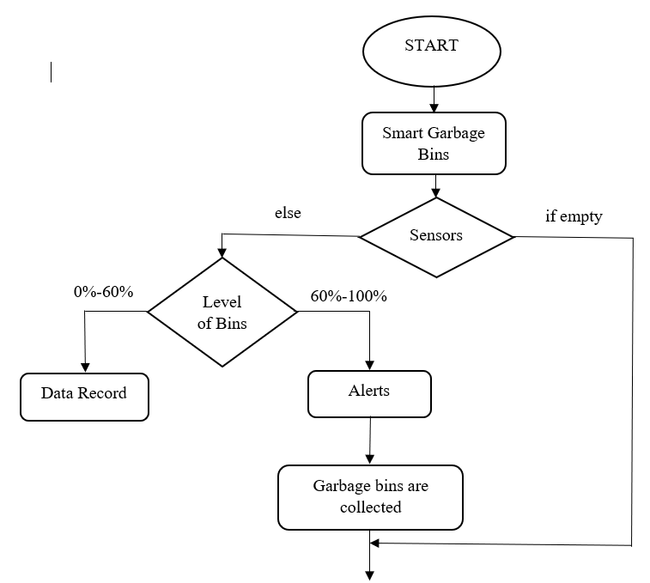

Figure 3. Flowchart

DISCUSSIONS
The aim here was to be able to control the management of waste efficiently so as to reduce pollution, littering of trash and toxic buildups. Based on other smart garbage systems, some modifications and improvements were made to the project. Using a cloud configuration along with an easy user interface and a quick response separates this project from the rest. The user data is constantly checked and updated to make sure any unwanted situations are avoided.

The smart garbage system is being tested in homes with the planned implementations. Ultrasonic sensors and humidity sensors are attached to these garbage bins. They actively measure the humidity and the distance between the lid and the level of garbage. When a threshold is reached alerts are sent to an app that alerts a garbage truck. Data was collected accordingly and careful observations were made on how the system performed. Customer reviews were collected on the product and its efficacy.

There were some problems observed while testing the product. The sensor updates and alerts, performed as expected but there was a lack of communication with garbage trucks. The garbage was not picked up when alerted. The sensors failed operation when in contact with liquid wastes. This could also potentially damage the sensors.

RESULTS

User’s Application
The MIT app inventor was used to create to applications. One for users and one for the owner. Here, the results from the user’s interface app is shown in figure 4. The customer enters their unique ID and information regarding their smart bin is displayed.

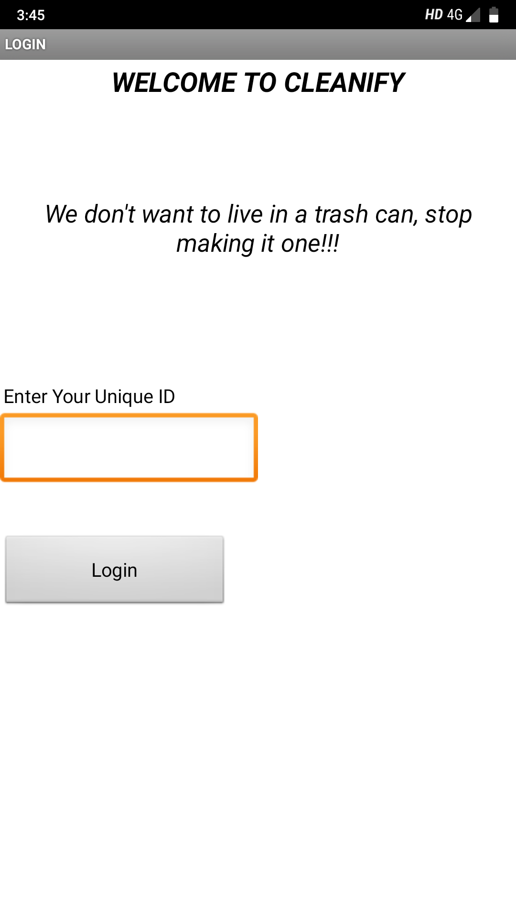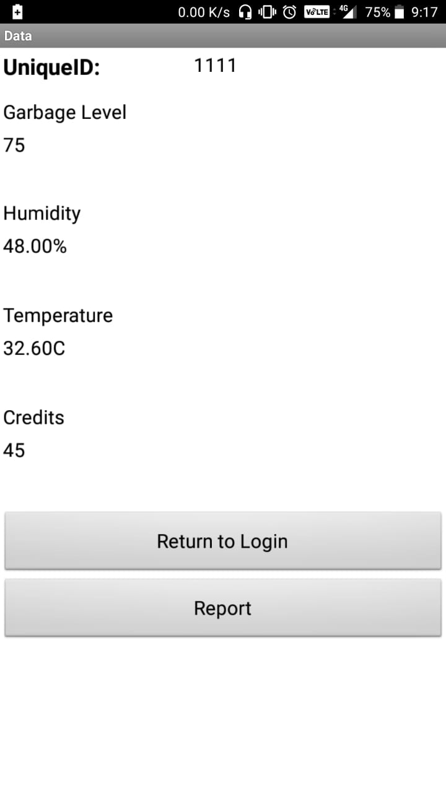
Figure 4. User’s Application

The user can also report trash accumulations in areas by entering the location of the trash on the report page and adding any necessary comments. The report page is shown in figure 5.

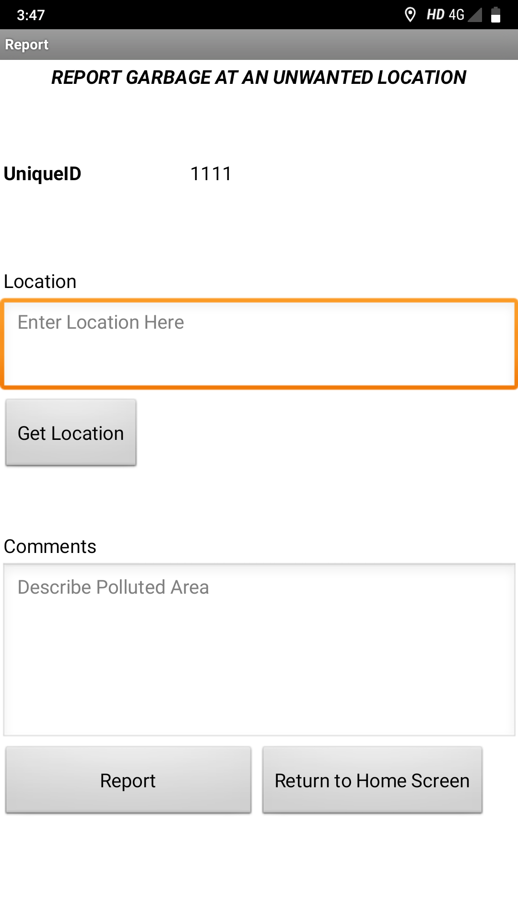
Figure 5. Reports

Owner’s Application
The owner controls the dispatch of garbage trucks and oversees the alerts and reports. In figure 6 it shows a report that a customer has placed. It has been accessed by the owner through the owner’s application.

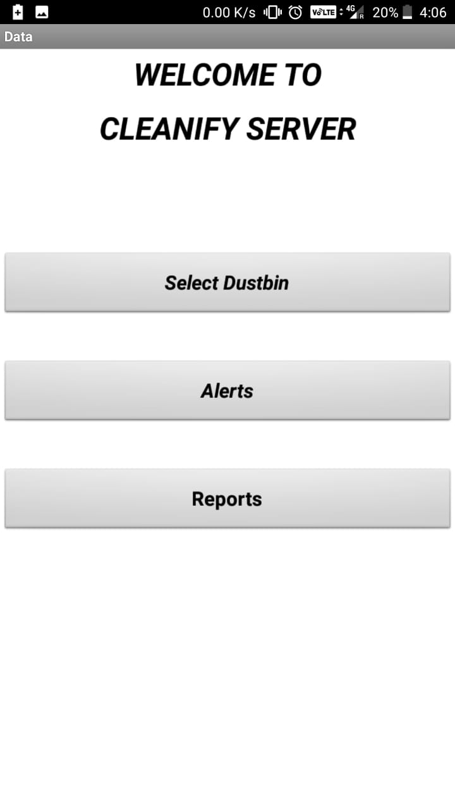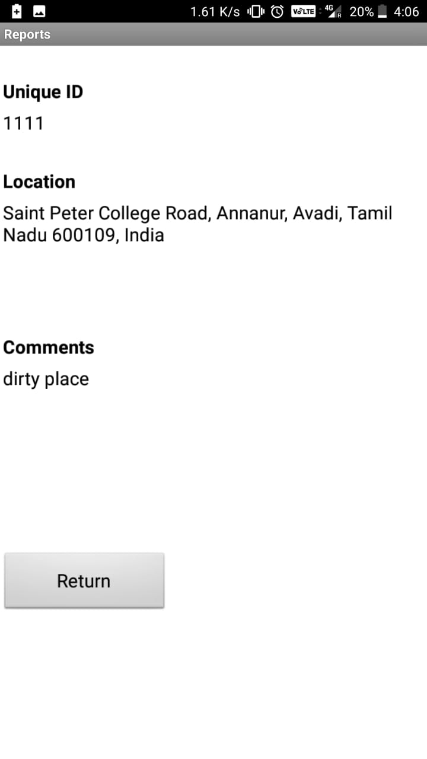
Figure 6. Owner’s Application

The owner can check the status of any dustbin at any given time by selecting the dustbin. To look at the alerts that have been sent in the owner can just open alerts and it displays a list of all the alerts that have been sent in along with their garbage levels and addresses. The alerts tab is shown in figure 7.

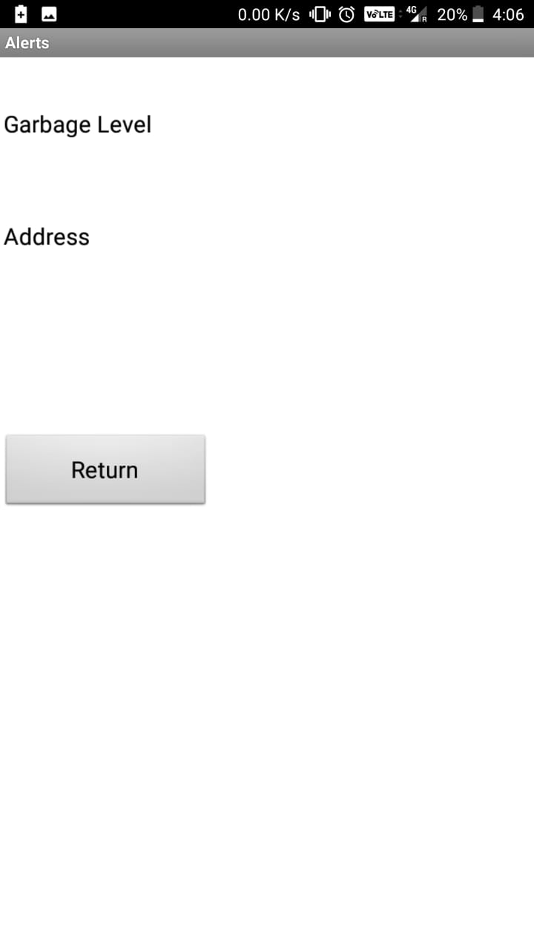
Figure 7. Alerts

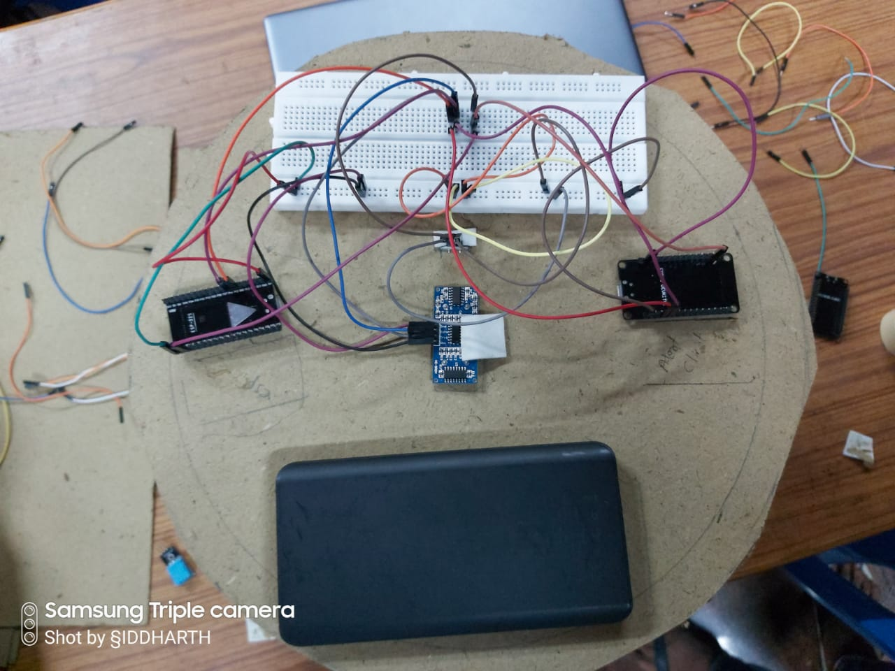
Figure 8. Final project

CONCLUSION
. Garbage piles is one of the main concerns of the society due to its impact on health and wellbeing of the people. The detection, monitoring and management of solid waste by the smart garbage monitoring system using the ESP32 microcontroller, helps to optimize solid waste collection keeping the environment clean and healthy. The proposed automated system is practicable, reliable, cost efficient and suitable to be implemented in homes, communities and all areas of the cities. The IoT garbage monitoring system is a step closer to a healthy living.

REFERENCES
- Hong, I., Park, S., Lee, B., Lee, J., Jeong, D., & Park, S. (2014). IoT-based smart garbage system for efficient food waste management. TheScientificWorldJournal, 2014, 646953. doi:10.1155/2014/646953. Retrieved from https://www.ncbi.nlm.nih.gov/pmc/articles/PMC4166430/
- Lakshmi, K. B., Kumar, M. S., Sindhuja, S., Padmavathy, R., & Jayabharathi, P. (2018). IoT Based Garbage Monitoring and Street Light Control. Asian Journal of Science and Applied Technology, 7(2), 33-37. Retrieved from http://www.trp.org.in/wp-content/uploads/2018/11/AJSAT-Vol.7-No.1-July-December-2018-pp.-33-37.pdf
- Mohd Yusof, N., Jidin, A. Z., & Rahim, M. I. (2017). Smart Garbage Monitoring System for Waste Management. MATEC Web of Conferences, 97, 01098.doi:10.1051/matecconf/20179701098. Retrieved from https://www.researchgate.net/publication/313252675_Smart_Garbage_Monitoring_System_for_Waste_Management
- Mustafa, M. R., & Azir, K. K. (2017). Smart Bin: Internet-of-Things Garbage Monitoring System. In MATEC Web of Conferences (Vol. 140, p. 01030). EDP Sciences. Retrieved from https://www.matec-conferences.org/articles/matecconf/abs/2017/54/matecconf_iceesi2017_01030/matecconf_iceesi2017_01030.html
- Patil, S., Zavare, S., Parashare, R., Rathod, P., & Babanne, V. (2017). Smart city waste management. International Journal of Engineering Science, 3990(7), 1. Retrieved from http://ijesc.org/upload/4babd33f6841ba0b9cff6671258aad25.Smart%20City%20Waste%20Management.pdf
- Suryawanshi, S., Bhuse, R., Gite, M., & Hande, D. (2018). Waste Management System Based On IoT. Waste Management, 5(03), 1-3. Retrieved from https://s3.amazonaws.com/academia.edu.documents/56785873/IRJET
- Zavare, S., Parashare, R., Patil, S., Rathod, P., & Babanne, V. (2017). Smart City waste management system using GSM. Int. J. Comput. Sci. Trends Technol, 5(3), 74-78. Retrieved from https://pdfs.semanticscholar.org/b110/1c032fe3ebaaef130c1e0622a3fe4f38b62b.pdf
- Dr. Sandeep M, Chaware1 , Shriram Dighe2 , Akshay Joshi3 , Namrata Bajare4 , Rohini Korke(2017). Smart Garbage monitoring system using IoT (Vol 5, Issue 1). Computer Engineering Dept, TSSM’S BSCOER, Narhe, Pune, India. Retrieved from
https://www.ijireeice.com/upload/2017/january-17/IJIREEICE%2015.pdf

 

